2.98: a) Let the height be h and denote the 1.30-s interval as t; the simultaneous equations h =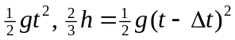 can be solved for t. Eliminating h and taking the square root, 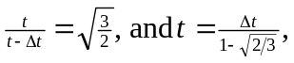 and substitution into 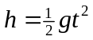gives h = 246 m.
This method avoids use of the quadratic formula; the quadratic formula is a generalization of the method of “completing the square”, and in the above form, 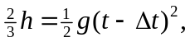 the square is already completed.

b) The above method assumed that t >0 when the square root was taken. The negative root (with Δt = 0) gives an answer of 2.51 m, clearly not a “cliff”. This would correspond to an object that was initially near the bottom of this “cliff” being thrown upward and taking 1.30 s to rise to the top and fall to the bottom. Although physically possible, the conditions of the problem preclude this answer.

